**Development environment**

1. **System information (server machine)**

* OS: Windows 7 pro (64bit)
* RAM: 8GB
* Processor: Core I7, 3.40GHz (8 CPUs), ~ 3.4GHz
* Monitor: 19 inches (1280 x 1024) (recommended)

1. **Environment information**
   1. Test Central site

http://192.168.190.122

* 1. Test Central database server
* IP address: 192.168.190.122
* Username: agile_test
* Password: agile_test@abc
* Port: 3308
* Database: test_central

*All above info are saved in ‘database.yml’ file*

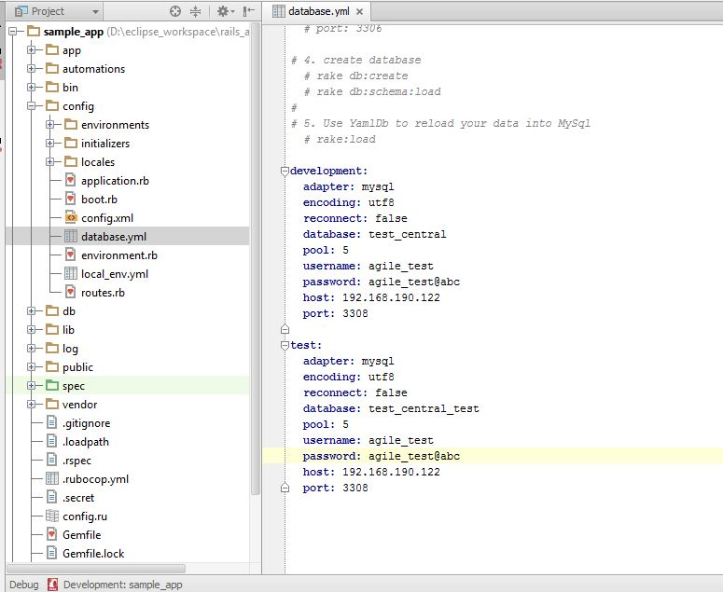

* 1. Automation database server
* IP address: 192.168.190.122
* Username: agile_test
* Password: agile_test@abc
* Port: 3308
* Databases:
  + - agile_local : contains test data for ATG Content, WebService
    - agile_local_ep: contains test data for EP Content

1. **Database:**

* MySQL 5.6
* MySQL Front version 5.3

1. **IDE**  
   Eclipse Java EE IDE for Web Developers

Version: Kepler Service Release 2

Build id: 20140224-0627

1. **Development Tools**
   1. SOAP UI Pro Trial
   2. Ruby 2.0 and Rails 4.1.1
   3. Ruby Gem List (*bundle install*): The list of gems is in Gemfile
2. **Eclipse plug-ins**

* Aptana - <http://download.aptana.com/studio3/plugin/install>
* To debug Rails Application
* dltk - <http://download.eclipse.org/technology/dltk/updates/>
* Source control: <http://subclipse.tigris.org/update_1.10.x>

1. **Source Code Repository**

<http://lotus.na.leapfrog.com:8080/systemsqa/rails_app>

1. **Git plug-ins (Source Codes Deployment and Control)**

* We often use Eclipse’s Git built-in plug-in to pull and push source code.
* Sometimes, if network is slow, we use “Git Development Community” for windows.

Download link: <http://git-scm.com/download/win>

1. **Firefox’s add-ons**

* **FireBug 2.0.4:** [https://getfirebug.com/firstrun#Firebug%202.0.4](https://getfirebug.com/firstrun%23Firebug%202.0.4)
* **FirePath 0.9.7:** <https://addons.mozilla.org/en-US/firefox/addon/firepath/>

FirePath is a Firebug extension that adds a development tool to edit, inspect and generate XPath 1.0 expressions, CSS 3 selectors and JQuery selectors

1. **Debugging**
   1. Use Eclipse debug
2. Install gem: ruby-debug-ide, debugger
3. Copy-paste folder “bin” and then rename to “script”

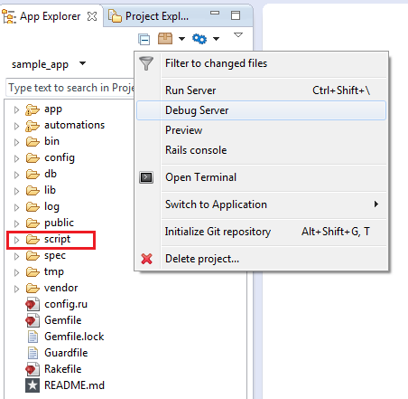

* 1. Use Ruby Mine debug

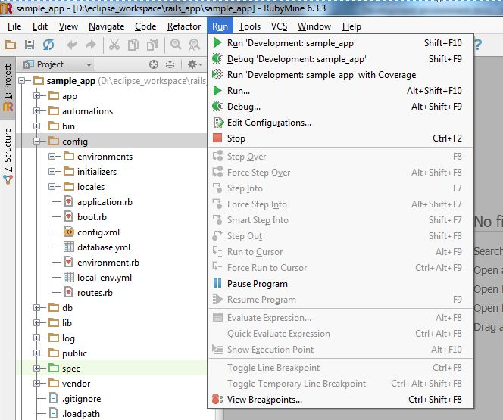

1. **Suggestion:**
   1. Using RubyMine for Automation Source Development

<http://www.jetbrains.com/ruby/>

* 1. Server for Automation Running in US side
* Deploy **Ruby** environment.
* Allow remote access
* LFQA and LGVN Team can access for running per requested.